**Bounding Salmon**

* Set up Trello: <https://trello.com/b/Dd74295h/project-board>

* Context: (what the site is going to be about/for) I am making a forum as a partner website for my bounding salmon website from last year.

* Purpose: There is a lack of good forums that are aesthetically pleasing especially for fishing specifically. My website should help address this issue. By providing a platform that is easy to use and aesthetically pleasing.
* End-user requirements: The forum will allow users to post threads, ask questions and provide answers questions using their accounts. It will also allow people to upvote questions like reddit. The home page of my site will show trending groups and the most upvoted groups, because this is a good place for new users to start. My website will also allow users to join selected groups and follow selected threads, so that posts relevant to them will appear on their ‘following’ page and also posts that they are following will send a notification when a new comment is made. My website will also allow users to search for specific posts and groups. Because of the nature of a forum my website will have to have strong administrative capabilities, as such my website will allow authorized users to block users, delete posts, remove comments etc.
* Stakeholders I will consult with: Dad, fishing groups, fishing buddies, Classmates, Mr Adams

Database Relevant Implications

Database

**Implication**: Sustainability and future proofing

**What it is** (in your own words): How easy the database is able to maintain and be updated with current information.

**Why is it important to your project and how will you address it**: Because my website is a forum website it needs to be able to be updated with relevant threads otherwise users would stop viewing it as the content will become outdated. I have to make sure that my database is easily accessible and can be managed through an interface on my website itself. This is so that admins are able to edit it without having to go through phpMyAdmin where they can easily make errors if they do not know what they are doing and damage the database. I have to make sure that I not only use appropriate types for database fields but also appropriate sizes as well. I also will make sure to following naming conventions such as all lowercase in the database with no spaces and camelCase in my website code. I will also have to comment where necessary to ensure that that my code is easy to update, and other developers are able to understand what is happening.

**Implication**: Privacy

**What it is** (in your own words): Not revealing information about my users as private information being easily accessible may be violating my user’s security.

**Why is it important to your project and how will you address it**: If I store my users private data such as passwords in my database unencrypted and my database is compromised then unauthorised users may be able to use their passwords against them and gain access to bank accounts and social media accounts etc. if they are using the same password. I will address this by storying the user’s password in the database only in encrypted form and nowhere will I store the user’s actual password.

Website Relevant Implications

**Implication**: Usability

**What it is** (in your own words): This is how easy my website it’s to use.

**Why is it important to your project and how will you address it**: This is relevant to my project as it is a fishing forum website and so users must be able to navigate and use my website without becoming frustrated which may cause them to leave to another competitor. Some of my audience may also be older or not as technologically literate and so may require the website to be as usable as possible. I can improve my website usability by making sure the search bar can access all the information in my database through key words as this is where most people look to find something specific. The results of the search will also need to be able to be reordered based on different sorting methods such as Latest, Most comments, oldest etc. I also have to appropriately follow hierarchy of headings and paragraphs etc. Navigation must also be as easy as possible and have multiple methods to arrive at the same destination so that my website is as easy to navigate as possible.

**Implication**: Aesthetics

**What it is** (in your own words): Adhering to natural and basic principles of creating an effective design that will engage the user for as long as possible.

**Why is it important to your project and how will you address it**: This is relevant to my project as it is a fishing article forum and so it must be aesthetically appealing in order for users to want to return to my website. This will also be a point of difference in my website as most other fishing forums look basic and unappealing. I will improve the aesthetics of my website by using white space effectively to improve readability. I must also be cautious in order to crowd the screen as many other fishing magazine type websites have done. I will also have to develop an effective colour scheme that relates to the target audience in some way. My layout and design will also have to constant through the website.

Research (screenshots, colour palettes, fonts, etc):

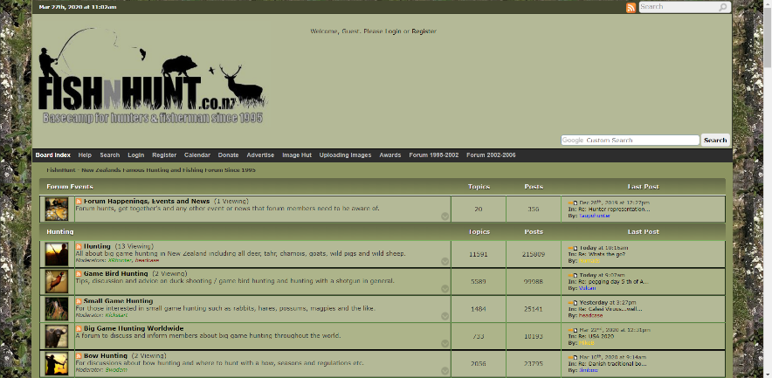

I like the way Fish N Hunt lays out and handles the forum idea by displaying the number of topics, number of posts and latest post inline.

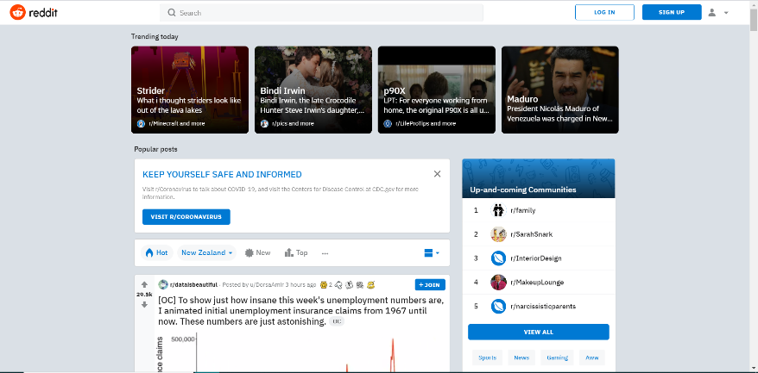

Reddit is perhaps the gold standard when it comes to forums, because of this I will be incorporating a lot of features and ideas from them.

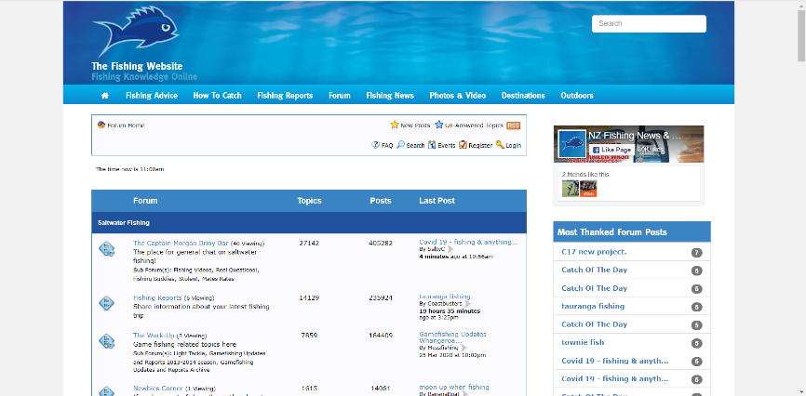

NZ fishing is one of the closest websites in New Zealand to perfecting the forum. NZ fishing handles the forum concept almost exactly the same as Fish N Hunt, as such I will be incorporating this into my design.

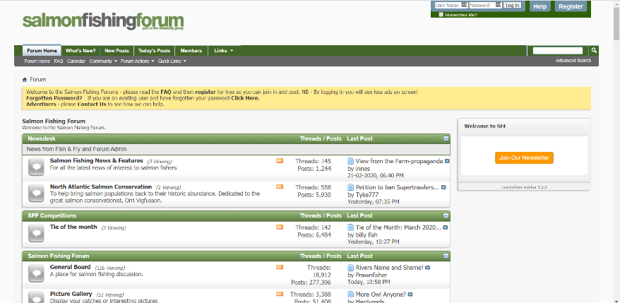

Salmonfishingforum has a very professional clean looking design which I would like my final design to imitate.

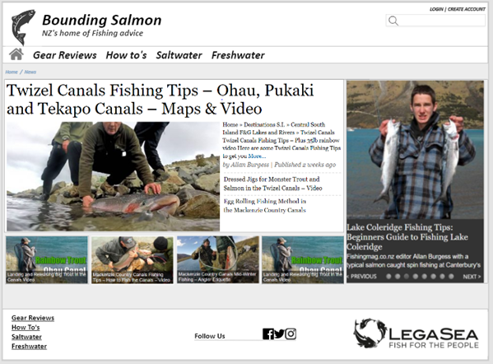

Since my website is going to be designed as a partner website from last year, I will be using the same colour scheme, layout and fonts so that they have a consistent theme.

Initial Design 1 Light:

**Search page**

**Home Page**

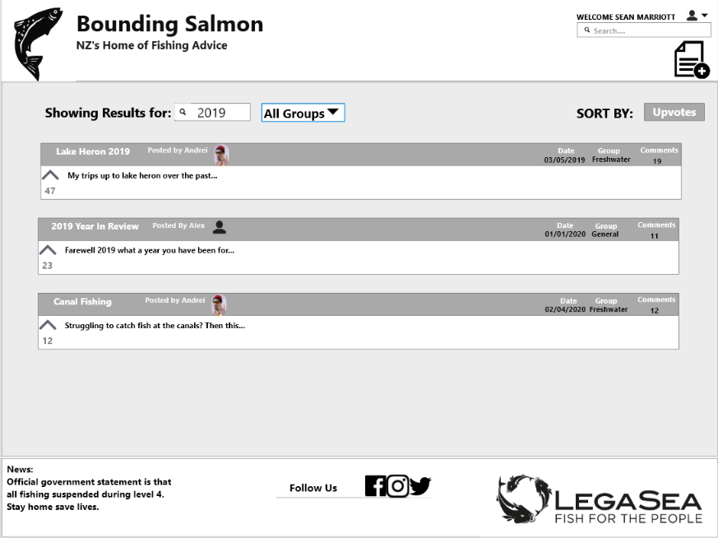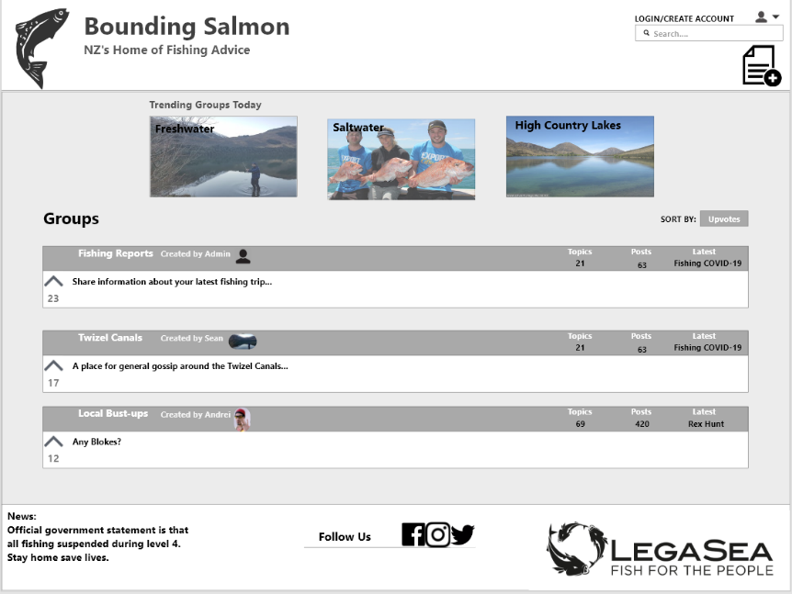

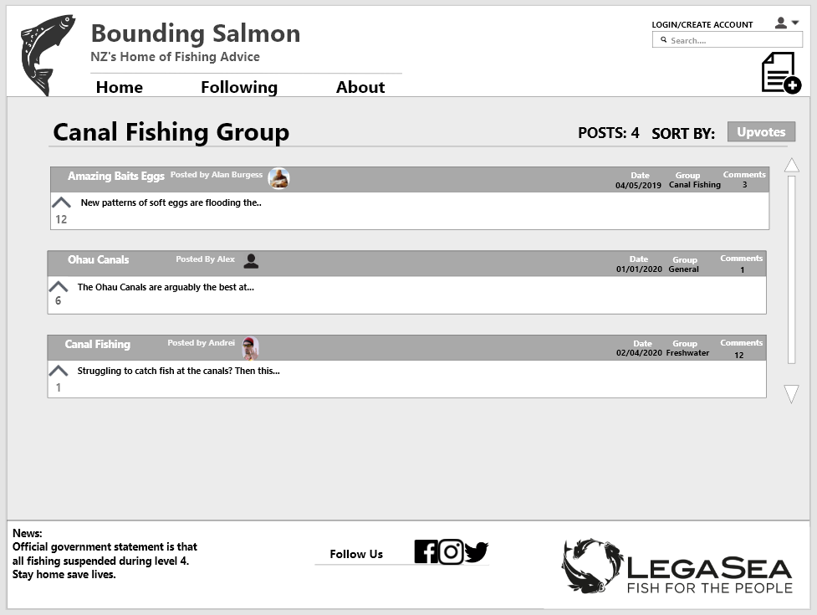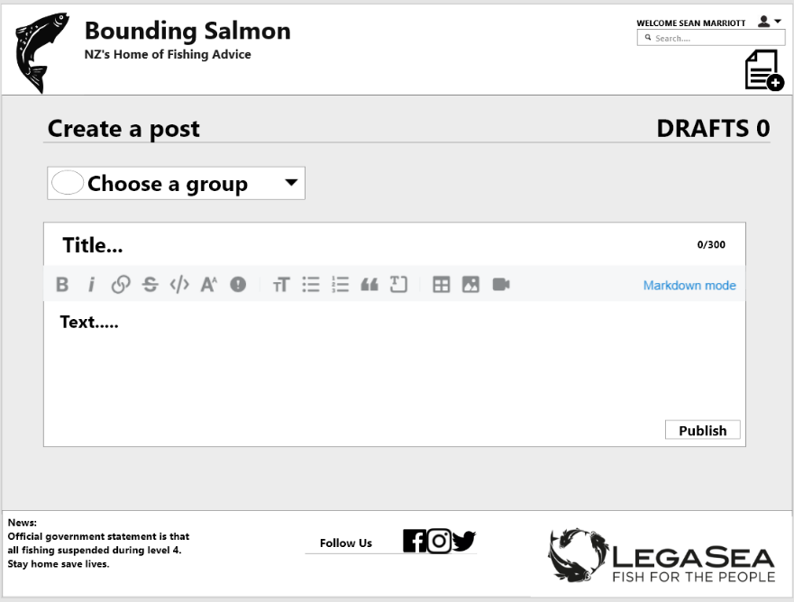

**Group Page**

**Create post page**

Initial Design 1 Dark:

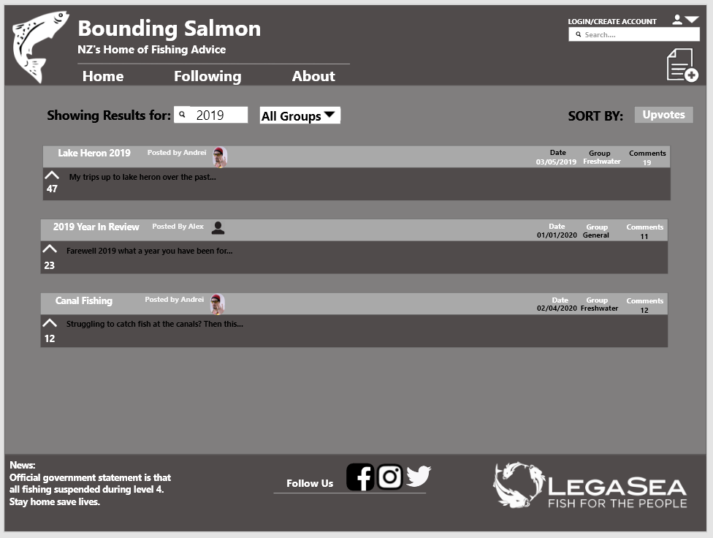

**Group Page**

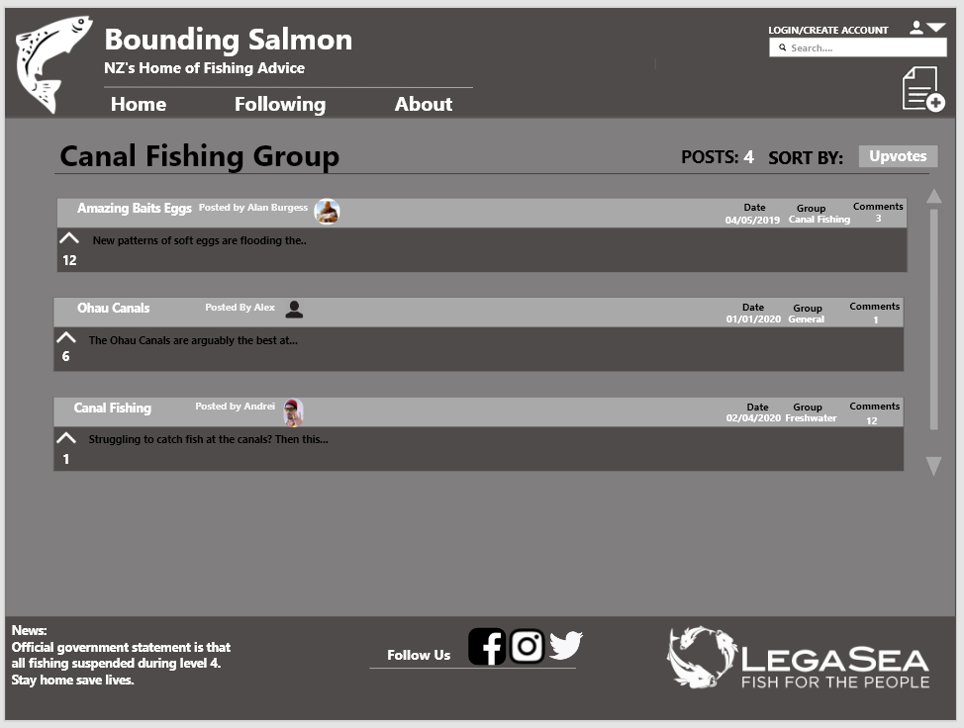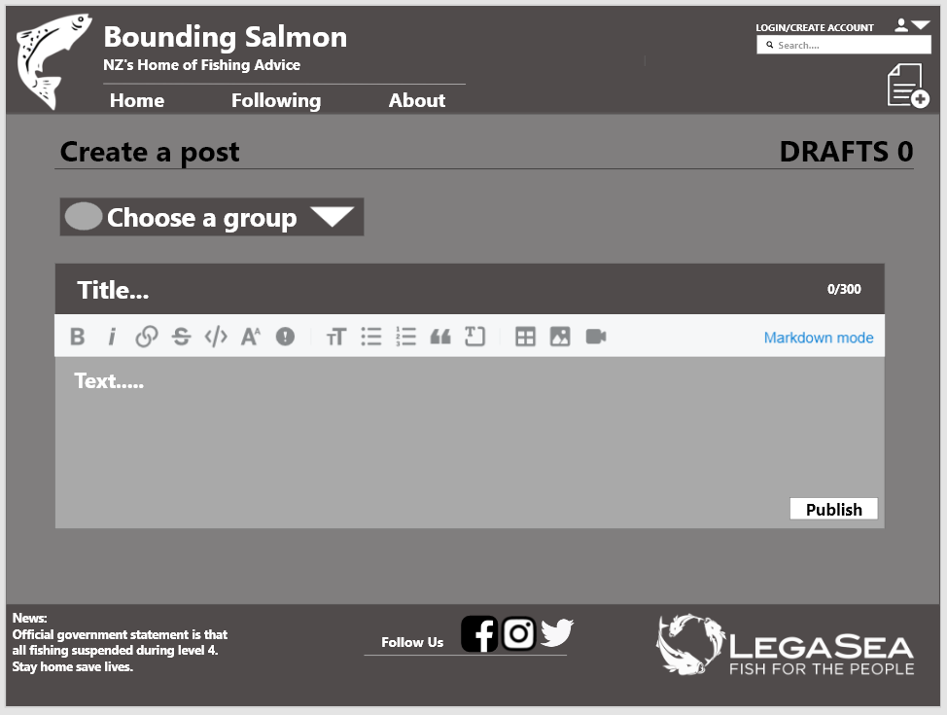

**Search page**

**Home Page**

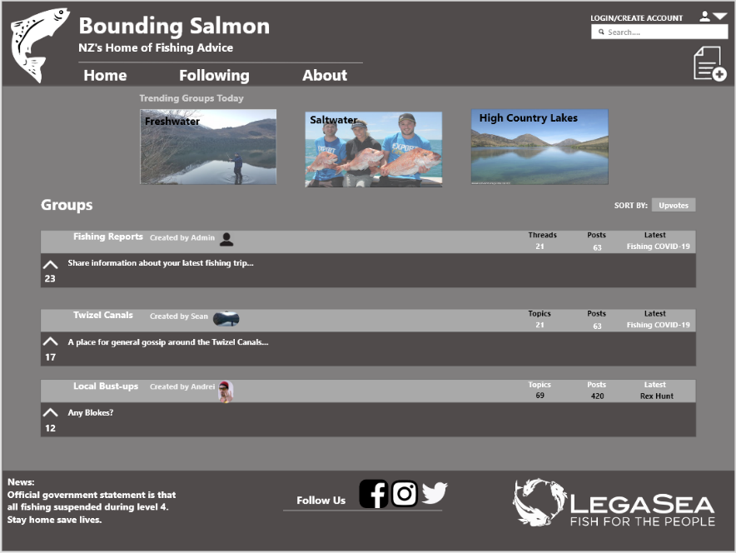



**Create post page**

Date: 4/05/2020

Name: Dad

Feedback: You should add a Navigation Bar as it would make your website a lot easier to navigate.

Changes made as a result of feedback: 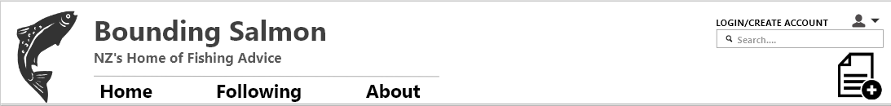

I did not implement this change until the day after when I got feedback from Neil to add a following page, as with out it the navbar seemed to empty and out of place.

Date: 5/05/2020

Name: Neil

Feedback: You should make a ‘following page’ where posts from groups you are following appear.

Changes made as a result of feedback:

The inclusion of a ‘following’ page is a great idea and will help set my page apart from other forum pages in NZ because to the best of my knowledge I do not think any include this feature. It will also help modernise my website and give users a reason to return to my website.

Date: 14/05/2020

Name: Mr Adams

Feedback: On the dark mode design the text in the dark grey boxes should be white like on the home page as the black text does not contrast enough.

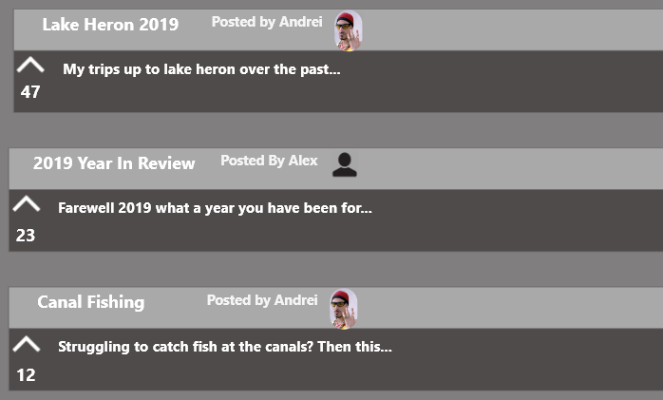Changes made as a result of feedback:

Database Design

|  |  |  |  |
| --- | --- | --- | --- |
| Table name: | Users | | |
| Column names | Data type | Length | Comment(s) |
| userID | Int | 2 | This is the user ID it will be the primary key for this table. It is the User’s unique numerical ID. |
| userImage | varchar | 50 | This will store the name and location of an image in the article. |
| userName | varchar | 50 | This is the name of the user. |
| userPassword | varchar | 100 | This is the user’s generated hash password. |
| admin | Int | 1 | This will be whether or not the account is an admin account if it is then it will be a 1 and it can perform administrate tasks, if it is not then it will be a 0 it can only post comments and make posts. |

|  |  |  |  |
| --- | --- | --- | --- |
| Table name: | Group | | |
| Column names | Data type | Length | Comment(s) |
| groupID | Int | 2 | This is the group ID it will be the primary key for this table. |
| userID | Int | 2 | This will get corresponding information from the user table e.g. username. |
| groupImage | varchar | 50 | This will store the name and location of the group image. |
| postID | Int | 2 | This will get corresponding information from the post table e.g. post content. |
| groupName | varchar | 50 | This is the name of the group |

|  |  |  |  |
| --- | --- | --- | --- |
| Table name: | comments | | |
| Column names | Data type | Length | Comment(s) |
| commentID | Int | 2 | This is the comment ID it will be the primary key for this table. |
| postID | Int | 2 | This is a common key with the post table it will determine which post the comment is displayed on. |
| userID | Int | 2 | This is the user ID it will be used to get corresponding information about the user. |
| commentContent | varchar | 5000 | This will be the content of the comment unsure of how long to make the length, may change. |
| date | date | n/a | This is the date the comment was created on. |

|  |  |  |  |
| --- | --- | --- | --- |
| Table name: | posts | | |
| Column names | Data type | Length | Comment(s) |
| postID | Int | 2 | This is the post ID it will be the primary key for this table. |
| UserID | Int | 2 | This is the user ID it will be used to get corresponding information about the user. |
| groupID | Int | 2 | This is the group ID it will be used to store the group that the post belongs to. |
| date | date | n/a | This is the date the post was created on. |
| postContents | varchar | 5000 | This will be the content of the post unsure of how long to make the length, may change. |
| postImage | varchar | 50 | This will store the name and location of the post image. |

Ongoing testing and development

Date: 22/05/2020

Student name: Dad

Feedback: You should put something that lets the viewer know when they are about to click on a link.

Changes made as a result of feedback:



As you can see when I hover over the Home link, it greys out, all the anchor tags on this website will grey out when hovered over.

Date: 02/06/2020

Student name: Charles

Feedback: When a user is logged in it should display that they are logged in.

Changes made as a result of feedback:

When the user is logged out



When the user is logged in



Date: 7/06/2020

Student name: Tyler

Feedback:

Admins should be able to delete or edit anyone’s comments not just theirs.

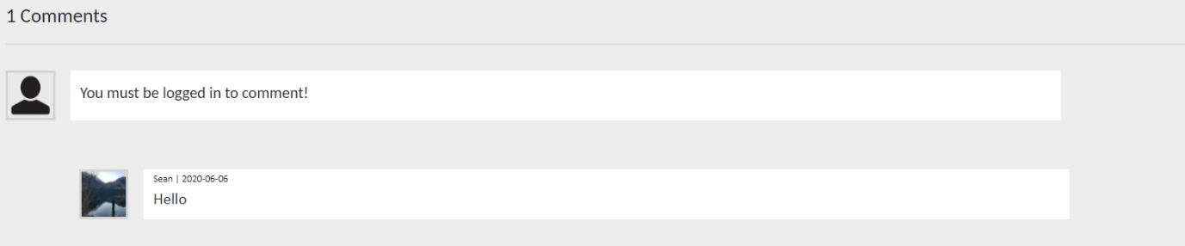

Changes made as a result of feedback:

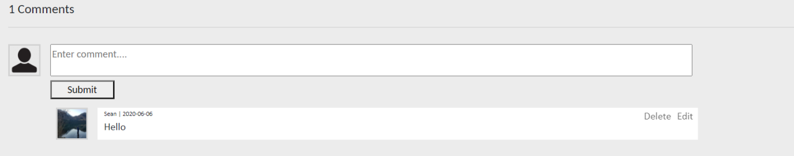

As you can an admin account can now remove comments even if they did not make them.

Date: 7/06/20

Student name: Mum

Feedback:

You should be able to delete or edit your posts from your account panel.

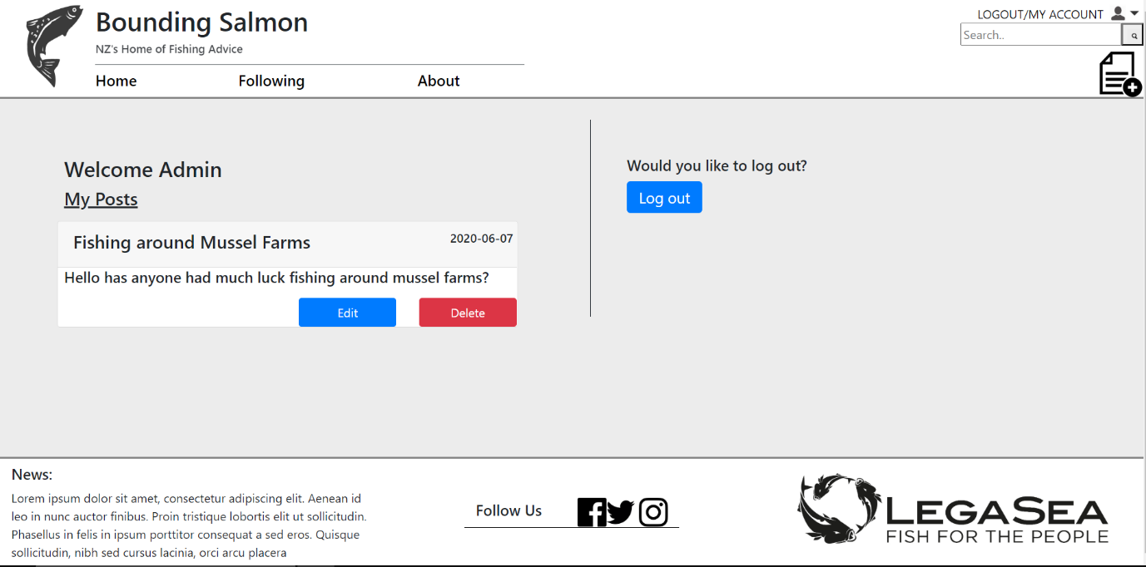

Trello

I used Trello as a way to break up tasks that needed to be completed, into smaller more manageable tasks. This also helped me know what tasks needed to be completed and how much I had left to do.

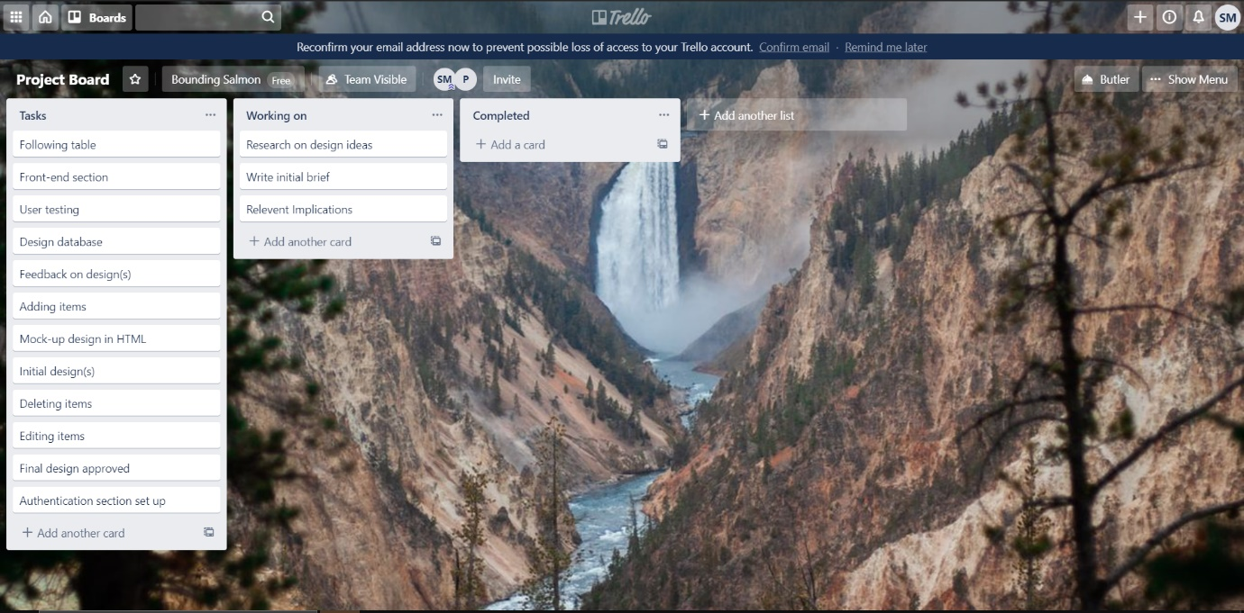

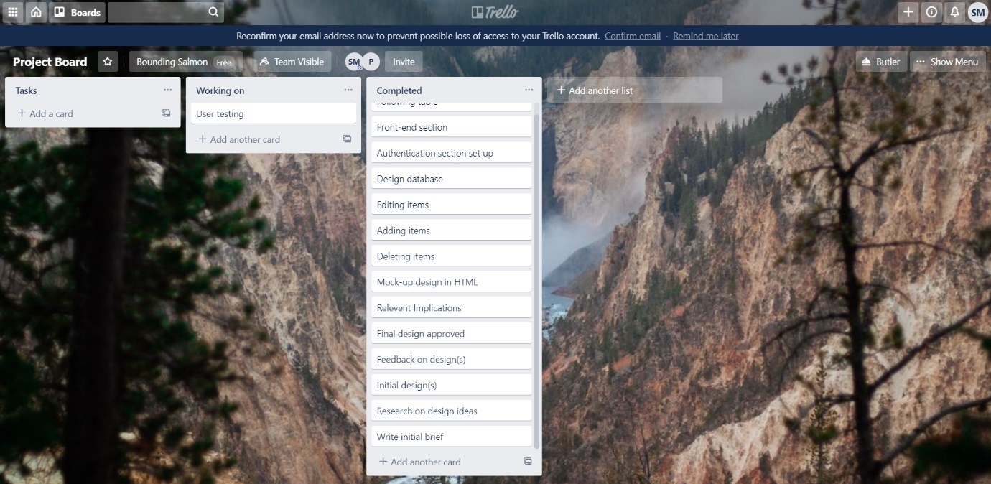

Final Evaluation

My final website has met the future proofing relevant implication by doing the following: I have chosen appropriate names for files to make it easier for other coders to work with my code as everything is named as expected. I have included comments on all of my code pages and also some of the database tables so people who look at it know what is happening at each stages of the code, allowing them to update it easier as they know what is happening and where. I have also made multiple php files which are included elsewhere in my code, this is so users can easily update common elements with changing it everywhere it is present in the code. Users are able to upload posts, edit posts, delete posts, upload comments, delete comments, edit comments, upload groups and delete groups, and signup new users all without entering the database and instead do it through the website, it is important that users are able to do this so that they can maintain and update the website for me.

My final website has met the usability heuristic by doing the following: I have followed design conventions such as the search bar being in the top right, logo top left, account above the search bar, social media links in the footer etc. which is falls under the consistency and standards heuristic. It is important that my website did this as users who have never visited the site before will be expecting this and if the website does not meet this expectation then it provides incentive for them to leave and find a different fishing forum etc. I have also provided different methods for the user to get the same post, they can search for it in the search bar or they can access it through the indivuial groups. It is important that my website does this as it makes the website more usable because if I only had one means of getting to a post for example the search bar, then if the user misses or does not understand how to work a search bar then the user will be unable to get to the desired post. I have also allowed the user to sort different posts and comments through different methods i.e. ascending and descending upvotes, this makes it easier for the user to find the specific posts they are after, if I did not do this then it makes the website harder to use providing the user a reason not to stay on the website. Users that have tested my website have not required assistance when testing my website so this is an indication that the website is easy to use.

End-user requirements: Explain how your design has addressed the purpose and end-user requirements you identified above. Justify decisions for Excellence.

I have addressed the purpose of the website which was to provide a forum for fishing that was both aesthetically pleasing and easy to use, and also the end user requirements of allowing users to create posts and create comments using their accounts. My website also allows people to upvote posts and groups like reddit. The home page of my site shows trending groups, the most upvoted groups, the least upvoted groups and the latest groups. My website also allows users to follow groups and by going to the following page see posts from groups that they are following. My website also allows users to search for specific posts and groups. My website also has strong administrative capabilities which include but is not limited to, allowing admins to delete and edit comments that are not theirs, deleting posts and groups. Users can search for posts in the search bar, users can sort posts by different orders, users can post comments about the posts, users can upload their own posts that belong to different groups. I have done this by providing a website which allows the user to read posts which can be organised categorically by different methods, providing a forum to the user about fishing in NZ where they could ask and answer questions etc. It is important that posts are organised categorically as it helps users find the posts that they are looking for. My website allows users to search for posts in the search bar, sort posts by different orders, allows users to post comments on posts and also allows users to upload their own posts. Admins are also able to remove or edit comments and posts, this is important in a forum environment as there is every possibility that individuals on the internet may use the platform to spread hate for example. My website is very easily updated, It is important that my website does this as it will quickly become irrelevant and outdated if users are unable to create their own posts and comments on them, It is also important that users are able to sort the articles as it means that they are able to find the article they are looking for easier, making the website more usable.